Project Structure:
Different visualisers to represent either the parsed Midi data (from a midi file) or Live Midi data (stream from a midi instrument).

Visualisers:
- Track Visualiser
- Piano Visualiser
- Drum Visualiser
- Sheet Music Visualiser,
(planned) abstract visualiser (OpenGL?)

Two major chunks of data
→ Header (only at the top of the file)
→ Track (can be several depending on the amount of instruments)

MIDI (Musical Instrument Digital Interface)

SMF = Standard Midi File
Runing Status byte

Hex editor images…

________________________________________________________________________________
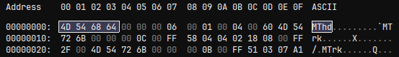
String of characters that tell us if the Midi file is a valid Midi file if it contains this sequence of characters that form the string “Mthd”. This is the start of our Midi Header chunk.

Reference:
"MThd" 4 bytes
the literal string MThd, or in hexadecimal notation: 0x4d546864. These four characters at the start of the MIDI file indicate that this is a MIDI file.
________________________________________________________________________________
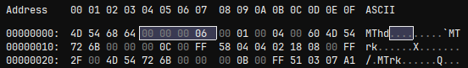
The length of the header chunk

Reference:
<header_length> 4 bytes
length of the header chunk (always 6 bytes long&emdash;the size of the next three fields).

________________________________________________________________________________Which Midi version the file uses. ‘1’ is the most common since it contains several tracks, while ‘0’ is very old and only uses a single track. ‘2’ is the newest but I haven’t found any Midi files that use this.

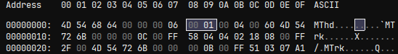
Reference:
<format> 2 bytes
0 = single track file format
1 = multiple track file format
2 = multiple song file format

________________________________________________________________________________
‘00 04’ is how many tracks are in this Midi file. This Midi only has 4 as shown by ‘04’ (Time Signature, Tempo, Kick Track, Snare Track). Some Digital Audio Workstations (DAWs) don’t export the ‘Set Tempo’ like LMMS which is why I had to use FL Studio so it would export this track.

Reference:
<n> 2 bytes
number of tracks that follow

‘00 60’ is the ‘Ticks per quarter note’ and it determines how fast the BPM will actually be in microseconds. The tick allows us to get an accurate delta time however we need to convert it to seconds to be used as our deltatime.
Tempo are how many microseconds are in a quarter note. We dived the tempo by 1 million to convert it to seconds.
To get it as a 'tick' we divide that new number in seconds by a large number (we can just use 24 for now and see what happens).
Reference:
<division> 2 bytes
unit of time for delta timing. If the value is positive, then it represents the units per beat. For example, +96 would mean 96 ticks per beat. If the value is negative, delta times are in SMPTE compatible units.
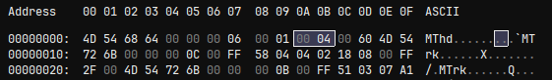
________________________________________________________________________________

This list of characters that say ‘MTrk’ stand for ‘Midi Track’. This tells us we have finished with the header chunk and have gotten to the first Midi Track.

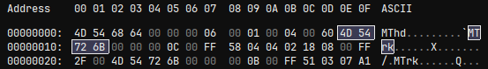
________________________________________________________________________________

This is the first Track chunk of the file, this is always going to be for the Time Signature which determines what timing each beat/measure is in (4/4, 3/4, 7/8 , etc).

Reference:
A track chunk consists of a literal identifier string, a length indicator specifying the size of the track, and actual event data making up the track.

track_chunk = "MTrk" + <length> + <track_event> [+ <track_event> ...]
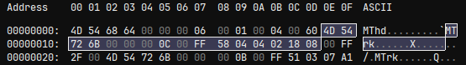
________________________________________________________________________________

Meta event type is 58 which is unique and is telling us it’s the Time Signature track.

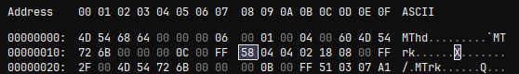

________________________________________________________________________________

The first 04 is the length. The next 04 is the nominator (4/4). The 02 is the denominator (4/4).
The denominator is stored as a power of 2 instead of the actual number 4. So we multiply the denominator by 2 to get the actual value (4).

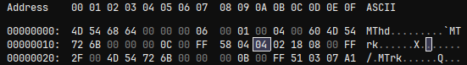

________________________________________________________________________________

The 18 is “Ticks per click” is how a DAW or Midi Player calculates the metronome timing which we won’t need to worry about since we are storing each note’s deltatime and assuming it’s always going to be quarter notes.

The 08 is the “Thirty second notes per crotchet” (crotchet is a musical term for quarter note), this is once again for DAWs to set notes as a specific length (1.16, 1/8, ¼ ,full measure, etc).

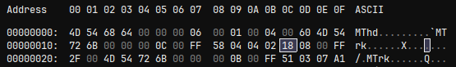
____________________________________________________________________________
temp…
(move this back up)

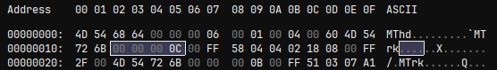

________________________________________________________________________________

temp…

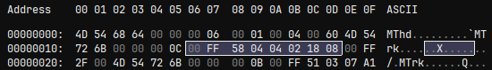
________________________________________________________________________________

End of meta event (00 FF) and end of track (2F 00).

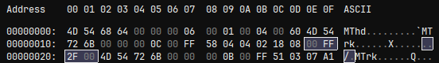

________________________________________________________________________________

Delta (to do)

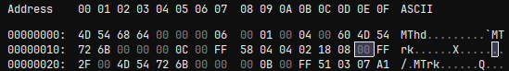

________________________________________________________________________________

2F is the meta event type which tells us this is the end of the track.

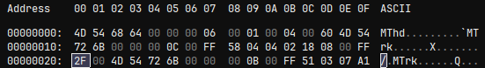
________________________________________________________________________________

00 is the number of bytes that come after the meta event, it’s 00 because there is no more data associated with this track. That’s another way to know we are moving onto the next track.

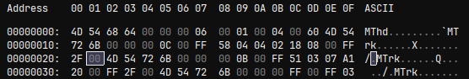
________________________________________________________________________________

The second track is the Tempo which will define our BPM speed.

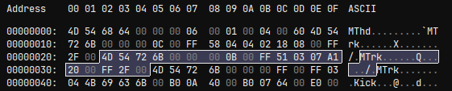
________________________________________________________________________________

“Mtrk” tells us it’s a track.

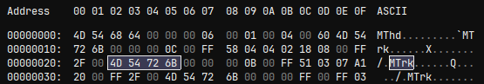
________________________________________________________________________________

Length of the track.

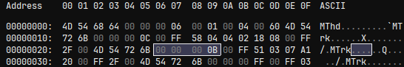

________________________________________________________________________________

00 FF is the status for a meta event.

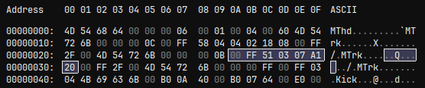
________________________________________________________________________________

51 tells us this is the meta type for “Set Tempo” .

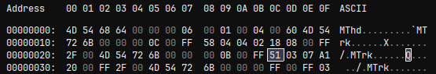

________________________________________________________________________________

temp…

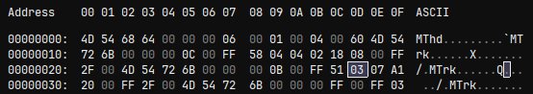
________________________________________________________________________________

This section is for “Microseconds per click”. We will need to convert this from microseconds to seconds when used in the game.

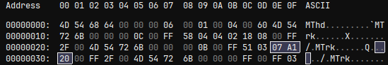
________________________________________________________________________________
Track 3 – First instrument track (instrument name: Kick)

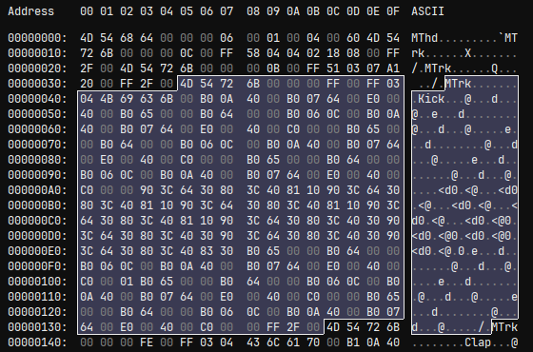

________________________________________________________________________________
temp…
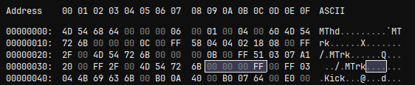
________________________________________________________________________________
temp…

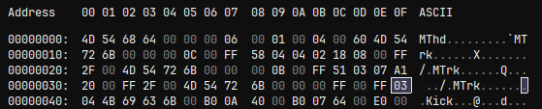
________________________________________________________________________________temp…

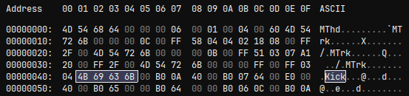
________________________________________________________________________________
temp…

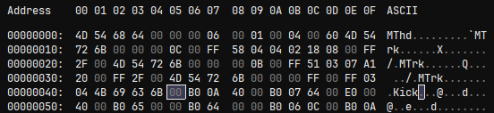
________________________________________________________________________________
temp…

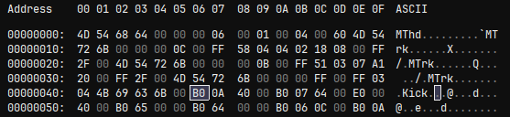

________________________________________________________________________________
temp…

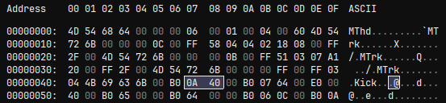
________________________________________________________________________________
temp…

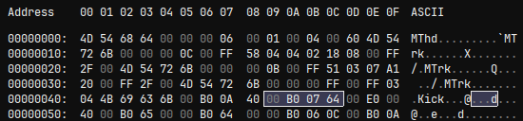
________________________________________________________________________________
temp…

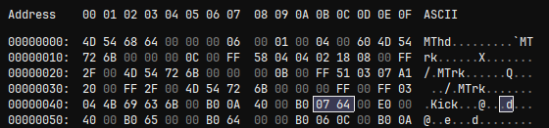

________________________________________________________________________________
temp…

________________________________________________________________________________
temp…

________________________________________________________________________________
temp…

________________________________________________________________________________
temp…

________________________________________________________________________________
temp…

________________________________________________________________________________
temp…

________________________________________________________________________________
temp…

________________________________________________________________________________
temp…

________________________________________________________________________________
temp…

________________________________________________________________________________
temp…

________________________________________________________________________________
temp…

________________________________________________________________________________
temp…

Midi Reference links:

